•**Brake:** A brake is a mechanical device that inhibits motion by absorbing energy from a moving system. It is used for slowing or stopping a moving vehicle, wheel, axle, or to prevent its motion, most often accomplished by means of friction..

BRAKES AND ITS TYPES

• Types of Car Brakes

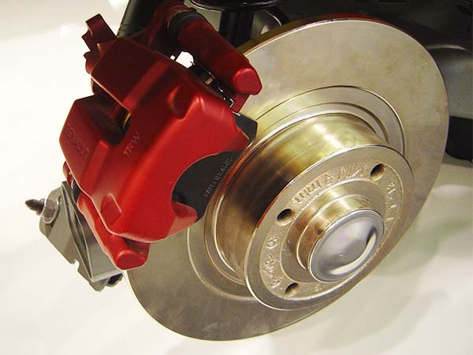 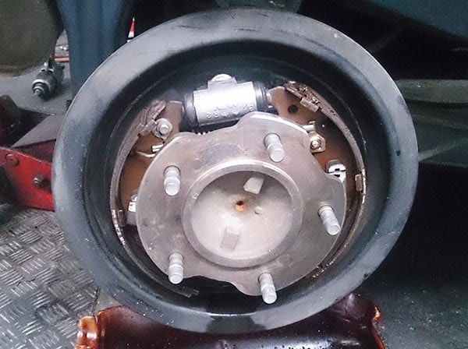

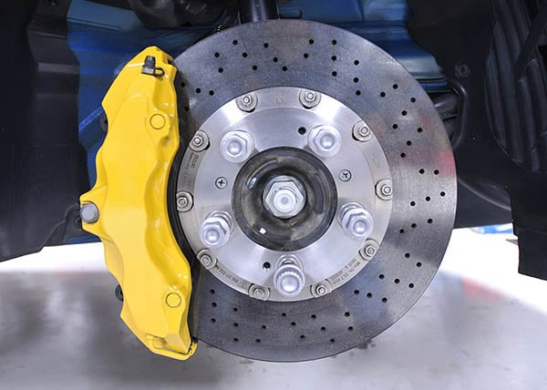**Disc Brakes Drum Brakes**

**Emergency Brakes**   **Anti-Lock Brakes**

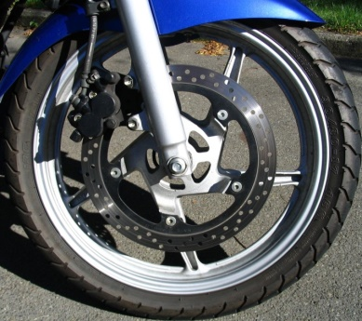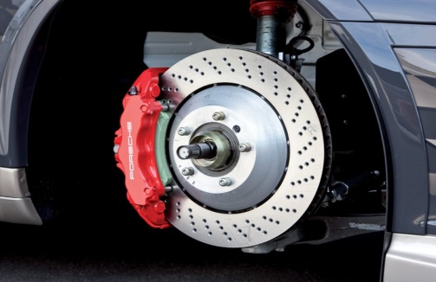

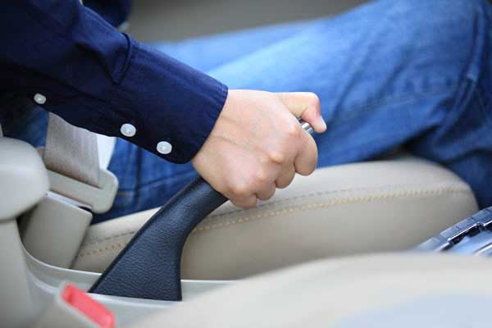

|  |
| --- |
| **PREPARED BY : 1)DHAKNE.R. MAHENDRA(22113),2)** **MOHAMMED.S.SAYYED(22114),3)JADHAV.S.MILIND(22115).** |
| **CLASS :ME-2-3I A.Y.-2020-21** |

**MGM’S POLYTECHNIC**

**AURANGABAD**

**Guided By: PROF. PARIHAR A.A**

